**A Project Report On**

**“Staff Management System”**

Submitted By

**Sayyed Shoaib Sohail**

**Khan Haaris Ikhlaque**

Guided By

**Prof. Mr. Suhail Sayyed**



**Department Of BCA(SCIENCE)**

**Abeda Inamdar Senior College (Autonomous)**

**[2023-24]**

**Abeda Inamdar Senior College, Pune**

**Abeda Inamdar Senior College, Department Of BCA(SCIENCE)**

ACKNOWLEDGEMENT

**It is my pleasure to acknowledge you that I have received a project on Staff Management System from my teacher.**

**My first sincere appreciation and gratitude goes to Prof Suhail Sayyed for her guidance, constructive comments, valuable suggestions and inspirations. During making of my Project he helped me a lot.**

**Finally, I wish to say thanks to all Faculties of BCA(Science) for helping me a lot.**

**TABLE OF CONTENTS**

**ABSTRACT vii**

1. **INTRODUCTION** 1
   1. Objective 1
2. **SYSTEM ANALYSIS 2**
   1. Existing System 3
   2. Proposed System 3
   3. Feasibility Study 3
      1. Economical Feasibility 4
      2. Technical Feasibility 4
      3. Operational Feasibility 4
3. **SYSTEM SPECIFICATION 5**
   1. Hardware Specification 5
   2. Software Specification 5
4. **SOFTWARE DESCRIPTION 6**
5. **PROJECT DESCRIPTION 9**
   1. Problem Definition 9
   2. Overview of The Project 9
   3. Module Description 9
   4. System Flow Diagram 12
   5. Data Flow Diagram 13
   6. System Design **15**
      1. Entity Relationship Diagram 15
      2. Use case Diagram 16
      3. Database Design 17
      4. Input Design 20
      5. Output Design 21
6. **SYSTEM IMPLEMENTATION 28**
   1. Purpose 28
   2. System Maintenance 29
7. **CONCLUSION AND FUTURE**

**30**

**ENHANCEMENTS**

* 1. Conclusion 30
  2. Scope For Future Development 30

1. **APPENDICES 37**

9.2 Screen Shots 50

**ABSTRACT**

**Stuaff Management System** deals with the maintenance of the student’s attendance details. It is generates the attendance of the student on basis of presence in class. It is maintained on the daily basis of their attendance. the staffs will be provided with the separate username & password to make the student’s status.

The staffs handling the particular subjects responsible to make the attendance for all students. Only if the student present on that particular period, the attendance will be calculated. The students attendance reports based on weekly and consolidate will be generated.

# CHAPTER 1 INTRODUCTION

**1.1 OBJECTIVE:**

“Staff Management System” is software developed for

maintaining the attendance of the student on the daily basis in the collage. Here the staffs, who are handling the subjects, will be responsible to mark the attendance of the students. Each staff will be given with a separate username and password based on the subject they handle. An accurate report based on the student attendance is generated here. This system will also help in evaluating attendance eligibility criteria of a student.

Report of the student’s attendance on weekly and monthly basis is generated.

**EISTING SYSTEM:**

The Existing system is a manual entry for the students. Here the attendance will be carried out in the hand written registers. It will be a tedious job to maintain the record for the user. The human effort is more here. The retrieval of the information is not as easy as the records are maintained in the hand written registers.

This application requires correct feed on input into the respective field. Suppose the wrong inputs are entered, the application resist to work. so the user find it difficult to use.

**2.1 PROPOSED SYSTEM:**

To overcome the drawbacks ofthe existing system, the proposed system has been evolved. This project aims to reduce the paper work and saving time to generate accurate results from the student’s attendance. The system provides with the best user interface.

The efficient reports can be generated by using this proposed system. **2.3.1 Advantages of Proposed System** ➢ It is trouble-free to use.

* It is a relatively fast approach to enter attendance
* Is highly reliable, approximate result from user
* Best user Interface
* Efficient reports

1. **FEASIBILITY STUDY:**

Feasibility analysis begins once the goals are defined. It starts by generating broad possible solutions, which are possible to give an indication of what the new system should look lime. This is where creativity and imagination are used. Analysts must think up new ways of doing things- generate new ideas. There is no need to go into the detailed system operation yet. The solution should provide enough information to make reasonable estimates about project cost and give users an indication of how the new system will fit into the organization. It is important not to exert considerable effort at this stage only to find out that the project is not worthwhile or that there is a need significantly change the original goal.

Feasibility of a new system means ensuring that the new system, which we are going to implement, is efficient and affordable. There are various types of feasibility to be determined. They are,

* 1. **Economically Feasibility:**

Development of this application is highly economically feasible. The only thing to be done is making an environment with an effective supervision.

It is cost effective in the sense that has eliminated the paper work completely. The system is also time effective because the calculations are automated which are made at the end of the month or as per the user requirement.

* 1. **Technical feasibility:**

The technical requirement for the system is economic and it does not use any other additional Hardware and software. Technical evaluation must also assess whether the existing systems can be upgraded to use the new technology and whether the organization has the expertise to use it.

Install all upgrades framework into the .Net package supported widows based application. this application depends on Microsoft office and intranet service ,database.

Enter their attendance and generate report to excel sheet.

* 1. **Operational Feasibility:**

The system working is quite easy to use and learn due to its simple but attractive interface. User requires no special training for operating the system. Technical performance include issues such as determining whether the system can provide the right information for the Department personnel student details, and whether the system can be organized so that it always delivers this information at the right place and on time using intranet services. Acceptance revolves around the current system and its personnel.

# CHAPTER 3 SYSTEM SPECIFICATION

## 3.1 HARDWARE REQUIREMENTS (Minimum Requirement)

* **Minimum RAM:-**1GB
* **Hard Disk:-**128 GB
* **Processor:-**Intel Pentium 4( 1.50 GHZ) or above

## SOFTWARE REQUIREMENTS (minimum Requirement)

* **Operating System - The website can be developed using any of the major**

**operating systems such as Windows, macOS, or Linux.**

* **Web Development Tools - The website will be developed using HTML,**

**CSS, JavaScript, and PHP programming languages. Text editors such as**

**Sublime Text or Visual Studio Code can be used for coding.**

* **Database Management System - A database management system such**

**as MySQL or PostgreSQL will be used for storing website data.**

* **Content Management System - A content management system such as**

**WordPress or Joomla can be used to facilitate the development and**

**management of the website.**

# CHAPTER 4 SOFTWARE DESCRIPTION

## 4.1 PACKAGE - VISUAL STUDIO 2010

**Microsoft Visual Studio** is an [integrated development environment](https://en.wikipedia.org/wiki/Integrated_development_environment) (IDE) from [Microsoft.I](https://en.wikipedia.org/wiki/Microsoft)t is used to develop [console a](https://en.wikipedia.org/wiki/Console_application)nd [graphical user interface](https://en.wikipedia.org/wiki/Graphical_user_interface) [applications a](https://en.wikipedia.org/wiki/Application_software)long with [Windows Forms o](https://en.wikipedia.org/wiki/Windows_Forms)r [WPF a](https://en.wikipedia.org/wiki/Windows_Presentation_Foundation)pplications, [web sites,](https://en.wikipedia.org/wiki/Web_site) [web applications,](https://en.wikipedia.org/wiki/Web_application) and [web services](https://en.wikipedia.org/wiki/Web_service) in both [native codet](https://en.wikipedia.org/wiki/Native_code)ogether with [managed code](https://en.wikipedia.org/wiki/Managed_code) for all platforms supported by [Microsoft Windows,](https://en.wikipedia.org/wiki/Microsoft_Windows) [Windows Mobile,](https://en.wikipedia.org/wiki/Windows_Mobile) [Windows CE,](https://en.wikipedia.org/wiki/Windows_CE) [.NET Framework,](https://en.wikipedia.org/wiki/.NET_Framework) [.NET Compact Framework a](https://en.wikipedia.org/wiki/.NET_Compact_Framework)nd [Microsoft Silver light.](https://en.wikipedia.org/wiki/Microsoft_Silverlight)

Visual Studio supports different [programming languages](https://en.wikipedia.org/wiki/Programming_language) by means of language services, which allow the code editor and debugger to support (to varying degrees) nearly any programming language, provided a language-specific service exists.

Visual Studio Code is a source-code editor that can be used with a variety of programming languages, including It is based on the [Electron](https://en.wikipedia.org/wiki/Electron_(software_framework)) framework,[[20]](https://en.wikipedia.org/wiki/Visual_Studio_Code#cite_note-ars-electron-20) which is used to develop [Node.js](https://en.wikipedia.org/wiki/Node.js) [web applications](https://en.wikipedia.org/wiki/Web_application) that run on the [Blink layout engine.](https://en.wikipedia.org/wiki/Blink_layout_engine) .

DEVELOPMENT TOOLS AND TECHNOLOGIES

HTML

The HyperText Markup Language or HTML is the standard [markup language](https://en.wikipedia.org/wiki/Markup_language) for documents designed to be displayed in a [web browser.](https://en.wikipedia.org/wiki/Web_browser) It is often assisted by technologies such as [Cascading Style Sheets](https://en.wikipedia.org/wiki/Cascading_Style_Sheets) (CSS) and [scripting languages](https://en.wikipedia.org/wiki/Scripting_language) such as [JavaScript.](https://en.wikipedia.org/wiki/JavaScript)

[Web browsers](https://en.wikipedia.org/wiki/Web_browser) receive HTML documents from a [web server](https://en.wikipedia.org/wiki/Web_server) or from local storage and [render](https://en.wikipedia.org/wiki/Browser_engine) the documents into multimedia web pages. HTML describes the structure of a [web page](https://en.wikipedia.org/wiki/Web_page) [semantically](https://en.wikipedia.org/wiki/Semantic_Web) and originally included cues for its appearance.

CSS:

Cascading Style Sheets (CSS) is a [style sheet language](https://en.wikipedia.org/wiki/Style_sheet_language) used for describing the [presentation](https://en.wikipedia.org/wiki/Presentation_semantics) of a document written in a [markup language](https://en.wikipedia.org/wiki/Markup_language) such as [HTML](https://en.wikipedia.org/wiki/HTML) or [XML](https://en.wikipedia.org/wiki/XML) (including XML dialects such as [SVG,](https://en.wikipedia.org/wiki/SVG) [MathML](https://en.wikipedia.org/wiki/MathML) or [XHTML)](https://en.wikipedia.org/wiki/XHTML)[.[1]](https://en.wikipedia.org/wiki/CSS#cite_note-1) CSS is a cornerstone technology of the [World Wide Web,](https://en.wikipedia.org/wiki/World_Wide_Web) alongside HTML and [JavaScript](https://en.wikipedia.org/wiki/JavaScript)[.[2]](https://en.wikipedia.org/wiki/CSS#cite_note-2)

CSS is designed to enable the [separation of content and presentation,](https://en.wikipedia.org/wiki/Separation_of_content_and_presentation) including [layout,](https://en.wikipedia.org/wiki/Page_layout) [colors,](https://en.wikipedia.org/wiki/Color) and [fonts](https://en.wikipedia.org/wiki/Typeface)[.[3]](https://en.wikipedia.org/wiki/CSS#cite_note-3) This separation can improve content [accessibility;](https://en.wikipedia.org/wiki/Accessibility) provide more flexibility and control in the specification of presentation characteristics; enable multiple [web pages](https://en.wikipedia.org/wiki/Web_page) to share formatting by specifying the relevant CSS in a separate .css file, which reduces complexity and repetition in the structural content; and enable the .css file to be [cached](https://en.wikipedia.org/wiki/Cache_(computing)) to improve the page load speed between the pages that share the file and its formatting.

JAVASCRIPT:

JavaScript , often abbreviated as JS, is a [programming language](https://en.wikipedia.org/wiki/Programming_language) that is one of the core technologies of the [World Wide Web,](https://en.wikipedia.org/wiki/World_Wide_Web) alongside [HTML](https://en.wikipedia.org/wiki/HTML) and [CSS.](https://en.wikipedia.org/wiki/CSS) As of 2022, 98% of [websites](https://en.wikipedia.org/wiki/Website) use JavaScript on the [client](https://en.wikipedia.org/wiki/Client_(computing)) side for [webpage](https://en.wikipedia.org/wiki/Web_page) behavior, often incorporating third-party [libraries.](https://en.wikipedia.org/wiki/Library_(computing)) All major [web browsers](https://en.wikipedia.org/wiki/Web_browser) have a dedicated [JavaScript engine](https://en.wikipedia.org/wiki/JavaScript_engine) to execute the [code](https://en.wikipedia.org/wiki/Source_code) on [users'](https://en.wikipedia.org/wiki/User_(computing)) devices.

JavaScript is a [high-level,](https://en.wikipedia.org/wiki/High-level_programming_language) often [just-in-time compiled](https://en.wikipedia.org/wiki/Just-in-time_compilation) language that conforms to the [ECMAScript](https://en.wikipedia.org/wiki/ECMAScript) standard.[[10]](https://en.wikipedia.org/wiki/JavaScript#cite_note-tc39-10) It has [dynamic typing,](https://en.wikipedia.org/wiki/Dynamic_typing) [prototype-based](https://en.wikipedia.org/wiki/Prototype-based_programming) [object-orientation,](https://en.wikipedia.org/wiki/Object-oriented_programming) and [first-class functions.](https://en.wikipedia.org/wiki/First-class_function) It is [multi-paradigm,](https://en.wikipedia.org/wiki/Programming_paradigm) supporting [eventdriven,](https://en.wikipedia.org/wiki/Event-driven_programming) [functional,](https://en.wikipedia.org/wiki/Functional_programming) and [imperative](https://en.wikipedia.org/wiki/Imperative_programming) [programming styles.](https://en.wikipedia.org/wiki/Programming_paradigm) It has [application programming interfaces](https://en.wikipedia.org/wiki/Application_programming_interface) (APIs) for working with text, dates, [regular expressions,](https://en.wikipedia.org/wiki/Regular_expression) standard [data structures,](https://en.wikipedia.org/wiki/Data_structure) and the [Document Object Model](https://en.wikipedia.org/wiki/Document_Object_Model) (DOM).

PHP:

PHP is a [general-purpose](https://en.wikipedia.org/wiki/General-purpose_programming_language) [scripting language](https://en.wikipedia.org/wiki/Scripting_language) geared toward [web development](https://en.wikipedia.org/wiki/Web_development)[.[8]](https://en.wikipedia.org/wiki/PHP#cite_note-8) It was originally created by DanishCanadian [programmer](https://en.wikipedia.org/wiki/Programmer) [Rasmus Lerdorf](https://en.wikipedia.org/wiki/Rasmus_Lerdorf) in 1993 and released in 1995.[[9](https://en.wikipedia.org/wiki/PHP#cite_note-:0-9)[][10]](https://en.wikipedia.org/wiki/PHP#cite_note-10) The PHP [reference implementation](https://en.wikipedia.org/wiki/Reference_implementation) is now produced by The PHP Group.[[11]](https://en.wikipedia.org/wiki/PHP#cite_note-about_PHP-11) PHP was originally an abbreviation of Personal Home Page,[[12](https://en.wikipedia.org/wiki/PHP#cite_note-History_of_PHP-12)[][13]](https://en.wikipedia.org/wiki/PHP#cite_note-13) but it now stands for the [recursive initialism](https://en.wikipedia.org/wiki/Recursive_initialism) PHP: Hypertext Preprocessor.[[14]](https://en.wikipedia.org/wiki/PHP#cite_note-14)

PHP code is usually processed on a [web server](https://en.wikipedia.org/wiki/Web_server) by a PHP [interpreter](https://en.wikipedia.org/wiki/Interpreter_(computing)) implemented as a [module,](https://en.wikipedia.org/wiki/Plugin_(computing)) a [daemon](https://en.wikipedia.org/wiki/Daemon_(computing)) or as a [Common Gateway Interface](https://en.wikipedia.org/wiki/Common_Gateway_Interface) (CGI) executable. On a web server, the result of the [interpreted](https://en.wikipedia.org/wiki/Interpreter_(computing)) and executed PHP code – which may be any type of data, such as generated [HTML](https://en.wikipedia.org/wiki/HTML) or [binary](https://en.wikipedia.org/wiki/Binary_number) image data – would form the whole or part of an [HTTP](https://en.wikipedia.org/wiki/Hypertext_Transfer_Protocol) response.

Structured Query Language, abbreviated as SQL (/ˌɛsˌkjuːˈɛl/ (listen) S-Q-L, sometimes /ˈsiːkwəl/ "sequel" for historical reasons),[4][5] is a domain-specific language used in programming and designed for managing data held in a relational database management system (RDBMS), or for stream processing in a relational data stream management system (RDSMS). It is particularly useful in handling structured data, i.e. data incorporating relations among entities and variables.

SQL offers two main advantages over older read–write APIs such as ISAM or VSAM. Firstly, it introduced the concept of accessing many records with one single command. Secondly, it eliminates the need to specify how to reach a record, e.g. with or without an index.

# CHAPTER 5 PROJECT DESCRIPTION

**5.1 PROBLEM DEFINITION:**

This system developed will reduce the manual work and avoid

redundant data. By maintaining the attendance manually, then efficient reports cannot be generated. The system can generate efficient weekly,consolidate report based on the attendance. As the attendances are maintained in registers it has been a tough task for admin and staff to maintain for long time. Instead the software can keep long and retrieve the information when needed.

## 5.2 PROJECT OVERVIEW

Staff Management System basically has two main modules for proper functioning

* Admin module is has rights for creating any new entry of faculty and student details.
* User has a rights of making daily attendance, generating report. Attendance report can be taken by given details of student details, date, class.

## 5.3 MODULE DESCRIPTION

The system should be designed in such a way that only authorized people should be allowed to access some particular modules. The records should be modified by only administrators and no one else. The user should always be in control of the application and not the vice versa.

The user interface should be consistent so that the user can handle the application with ease and speed. The application should be visually, conceptually clear.

**5.3.1 ADMINISTRATOR MODULE:**

**Student Details:**

In this module deals with the allocation of roll no and personal details for new batch.It will generate of personal details of student and academic details of the students with the photos.

**Staff Details:**

It helps to allot the subject and the subject code to the particular staffs.

It provides the facility to have a user name and password to the staffs .

**Attendance details:**

It will be makes to the attendance database all students. Entered attendance to stored in the database subject ,period wise into the particular date.

It will help s to the get report of weekly and consolidate of the attendance.

**5.3.2 STAFFS MODULE:**

**Attendance details:**

➢ It assists the staff to mark attendance to the students for their subject. This will authenticate the staff before making the entry.

**5.4 SYSTEM FLOW DIAGRAM:**

Figure 5.4-System Flow Diagram

## 5.5 Data Flow Diagram

**5.5.1 DFD level 0:**

DATABASE



Figure 5.5.1-DataFlowDiagram Level1

**5.5.2 DFD level 1:**

Figure

5.5.2

-

DataFlowDiagram

Level1



**5.5.3 DFD level 2:**

**5.5.3.1 Admin:**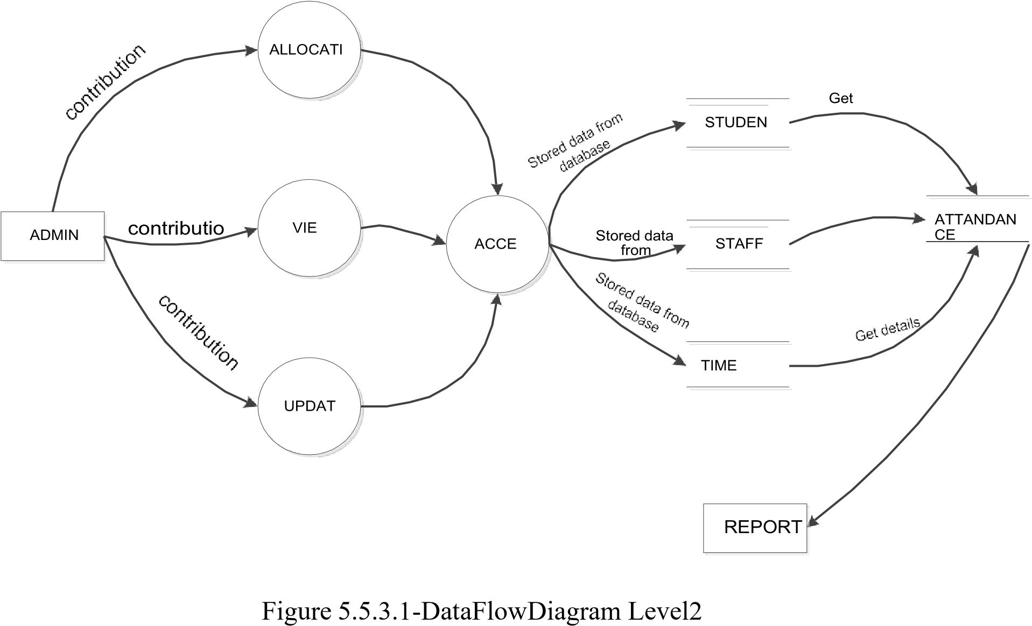

**5.5.3.2**

**staffs:**

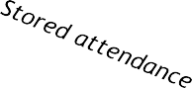

Figure 5.5.3.2-DataFlowDiagram Level2

**5.6 SYSTEM DESIGN:**

**5.6.1 Entity Relationship Diagram:**

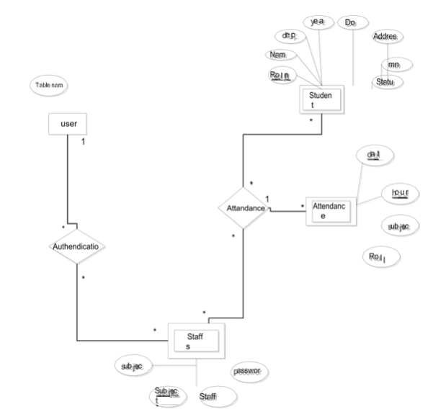

Figure 5.6.1-Entity Relationship Diagram

**5.6.2 Use case Diagram:**

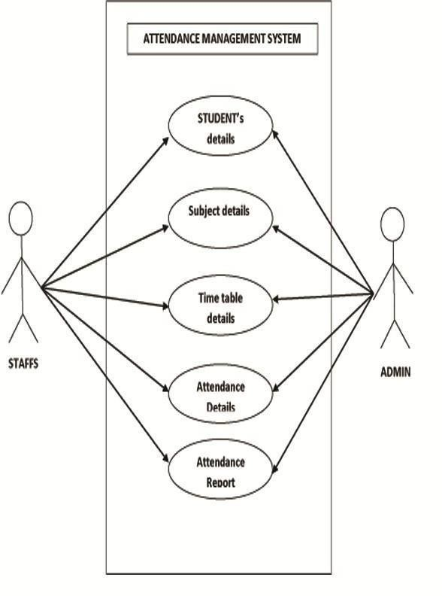

### Figure:5.6.2 -Use case Diagram

**5.6.2 Database :**

* **Teachers**

* **Students**

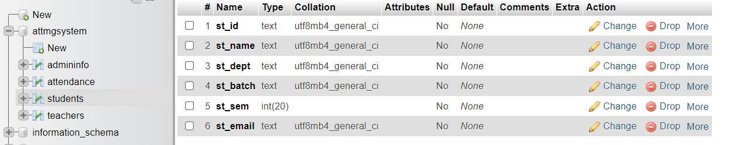

* **Admin Info**

* **Attendance**

## 5.6.3 INPUT DESIGN

Input design is part of overall system design that requires special attention designing input data is to make the data entered easy and free from **errors**. The input forms are designed using the controls available in .NET framework. Validation is made for each and every data that is entered. Help information is provided for the users during when the customer feels difficult.

Input design is the process of converting the user originated inputs to a computer based format. A system user interacting through a workstation must be able to tell the system whether to accept the input to produce reports. The collection of input data is considered to be most expensive part of the system design. Since the input has to be planned in such a manner so as to get relevant information, extreme care is taken to obtain pertinent information

This project first will entered to the input of allocation forms it will be created on student details form and subject entry form, time table form .it will helps to calculate subject wise attendance system. next one if u want any verification on your data’s also available in details show forms. Attendance to entered single subject wise or all subject wise attendance system available in this project.

## 5.6.4 OUTPUT DESIGN

Output design this application “**Staff Management System”** generally refers to the results and information that are generated by the system for many end-users; output is the main reason for developing the system and the basis on which they evaluate the usefulness of the application.

The output is designed in such a way that it is attractive, convenient and informative. Forms are designed with various features, which make the console output more pleasing.

As the outputs are the most important sources of information to the users, better design should improve the system’s relationships with us and also will help in decision making. Form design elaborates the way output is presented and the layout available for capturing information.

One of the most important factors of the system is the output it produces. This system refers to the results and information generated. Basically the output from a computer system is used to communicate the result of processing to the user.

Staff Management System to show the report subject wise attendance maintaining by staffs. Taken as a whole report obtain on a administrator privileges only. this forms will show weekly report and consolidate report generated date, batch, and class wise to our end user. we want to change our report to convert Excel format .if you want change any modification.

# CHAPTER 7 SYSTEM IMPLEMENTATION

## 7.1 Purpose

System implementation is the important stage of project when the theoretical design is tuned into practical system. The main stages in the implementation are as follows:

* Planning
* Training
* System testing and
* Changeover Planning

Planning is the first task in the system implementation. At the time of implementation of any system people from different departments and system analysis involve. They are confirmed to practical problem of controlling various activities of people outside their own data processing departments.

The line managers controlled through an implementation coordinating committee. The committee considers ideas, problems and complaints of user department, it must also consider:

* The implication of system environment
* Self selection and allocation for implementation tasks
* Consultation with unions and resources available
* Standby facilities and channels of communication

Student Staff Management System will implement student details ,staff handle subjects details, separate login details ,time table details. It will used to entered subject wise attendance .This application elaborate attendance table generate weekly, consolidate report provide to the End user. Mostly this application will calculate date wise attendance .To select starting date to end date generate reports at the time of activities.

## 7.2 SYSTEM MAINTENANCE

Software maintenance is far more than finding mistakes. Provision must be made for environment changes, which may affect either the computer, or other parts of the computer based systems. Such activity is normally called maintenance. It includes both the improvement of the system functions and the corrections of faults, which arise during the operation of a new system.

It may involve the continuing involvement of a large proportion of computer department recourses. The main task may be to adapt existing systems in a changing environment.

Back up for the entire database files are taken and stored in storage devices like flash drives, pen drives and disks so that it is possible to restore the system at the earliest. If there is a breakdown or collapse, then the system gives provision to restore database files. Storing data in a separate secondary device leads to an effective and efficient maintains of the system. The nominated person has sufficient knowledge of the organization’s computer passed based system to be able to judge the relevance of each proposed change.

# CHAPTER 8

# CONCLUSION AND FUTURE ENHANCEMENT

## 8.1 Conclusion

To conclude, Project Data Grid works like a component which can access all the databases and picks up different functions. It overcomes the many limitations incorporated in the attendance.

* Easy implementation Environment
* Generate report Flexibly

## 8.2 Scope for future development

The project has a very vast scope in future. The project can be implemented on intranet in future. Project can be updated in near future as and when requirement for the same arises, as it is very flexible in terms of expansion. With the proposed software of database Space Manager ready and fully functional the client is now able to manage and hence run the entire work in a much better, accurate and error free manner. The following are the future scope for the project. ➢ Discontinue of particular student eliminate potential attendance.

* Bar code Reader based attendance system.
* Individual Attendance system With photo using Student login.

**9.2 Screen Shots:**

**9.2.1 LOGIN:**

**9.2.2 Registrtion:**

**9.2.3 Students Details:**

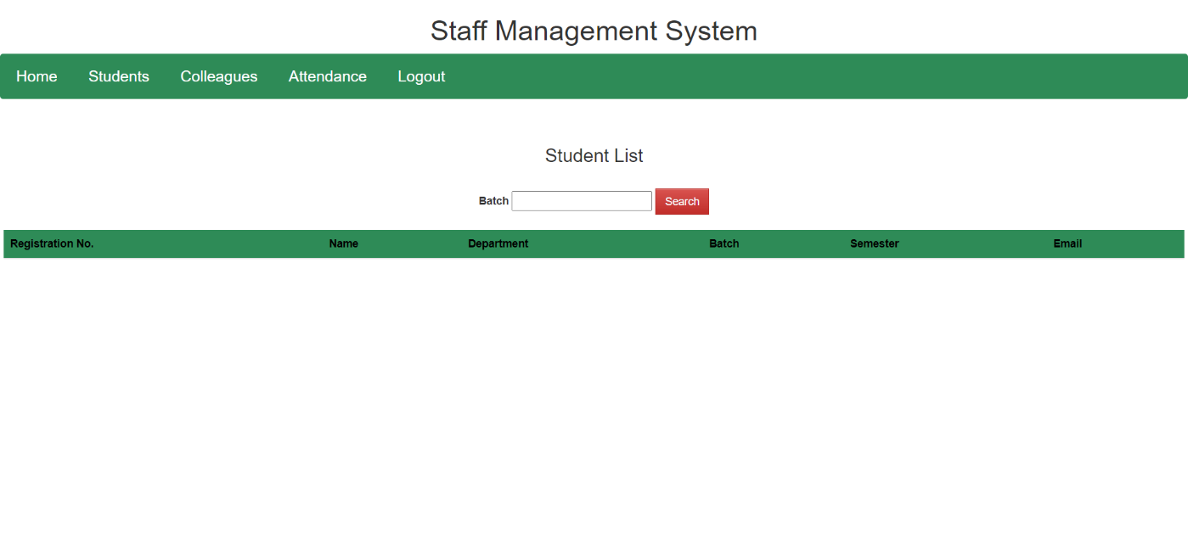

**9.2.4 Teachers Details:**

**9.2.5 Attendance:**

**Bibliography**

* W3Schools Online Web Tutorials: <https://www.w3schools.com/>.
* MySQL: https://dev.mysql.com/doc/
* Official Bootstrap: https://getbootstrap.com/docs/5.1/getting-started/introduction/
* PHP: https://www.php.net/docs.php
* XAMPP User Guide: https://www.apachefriends.org/docs/